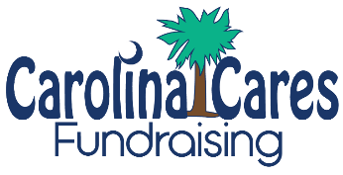

Joyful Traditions® Cake Rolls Fundraiser Kickoff!

Thank you for supporting the (GROUP NAME) Joyful Traditions Cake Rolls Fundraiser! We are raising money for (FUNDRAISER PURPOSE). Each person has a goal to sell (XX) items.

Please note the following:
- Joyful Traditions Cake Rolls are 15.5 – 19.5 oz mouthwatering cake rolled around a delicious cream filling. They are perfect for Holidays, Family Gatherings, or any day that you want a quick and easy dessert. They are exclusive to fundraising, so be sure to purchase more than one!
- Our Selling Price – $16 Our Profit – 40%
- Collect Payment as You Sell (Checks Made Payable to: XXX)
- Online Ordering Available! tinyurl.com/XXX
- Order Forms and Payment Due By: XX/XX/XXXX
- Flavors: Carrot, Chocolate Crème, Lemon Crème, Pumpkin, Red Velvet, Strawberry Cheesecake
ONLINE ORDERING

(Paste QR Code Here)

Delivery Process
- Week of: XX/XX/XXXX
- Orders will be sorted, boxed, and labeled by Seller
- Each case will have up to 8 items
- Please return your items to a freezer within 2 hours of pick up

Q. What is the #1 reason people don’t support a fundraiser?
A. They were never asked!

Thank you for your support,
(GROUP LEADER NAME)

