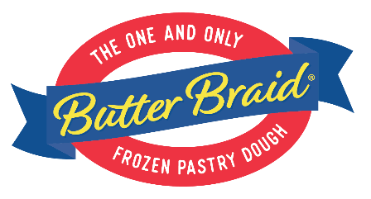

Butter Braid Pastry Dough Fundraiser Kickoff!

Thank you for supporting the (Group Name) Butter Braid Pastry Dough Fundraiser! We are raising money for (Fundraiser Purpose). Each person has a goal to sell (Sales Goal) items.

Please note the following:
- Butter Braid Pastry Dough is frozen pastry dough that you bake yourself. They are perfect for Holidays, Family Gatherings, or any day that you want Homemade Tasting pastries. They will keep in your freezer for months, so be sure to purchase more than one!
- Our Selling Price – $16 Our Profit – 40%
- Collect Payment as You Sell (Checks Made Payable to: XXX)
- Online Ordering Available! tinyurl.com/XXX
- Order Forms and Payment Due By: XX/XX/XXXX
- Flavors: Apple, Bavarian Crème w/ Chocolate icing, Blueberry & Cream Cheese, Cinnamon, Strawberry & Cream Cheese

Delivery Process
- Week of: XX/XX/XXXX
- Orders will be sorted, boxed, and labeled by Seller
- Each case will have up to 7 items
- Please return your items to a freezer within 2 hours of pick up

Q. What is the #1 reason people don’t support a fundraiser?
A. They were never asked!

Thank you for your support,
(Group Leader Name)

