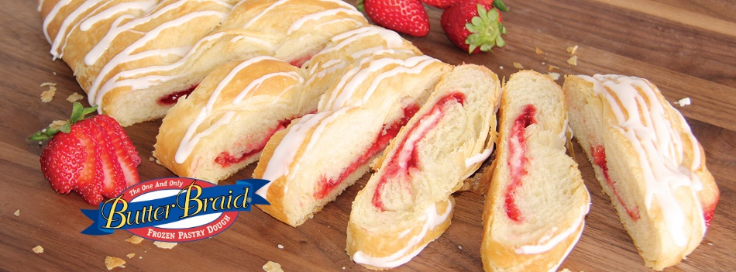

Butter Braid Pastry Fundraiser Kickoff!
Thank you for supporting the Insert Group Name Butter Braid pastry fundraiser! We are raising money for Insert Fundraiser Purpose. Each person has a goal to sell XX items.
Please note the following:
- Butter Braid pastries are frozen pastry dough that you bake yourself. They are perfect for holidays, special occasions, or any day that you want a fresh baked treat! They will keep in your freezer for months…so be sure to purchase more than one.
- Retail Price – $14 Our Profit – $6
- Collect Payment as You Sell (Checks Made Payable to: Group Name)
- Order Forms and Payment Due By: 01/01/2000
- Flavors: Apple, Blueberry & Cream Cheese, Cinnamon, Double Chocolate, Strawberry & Cream Cheese

Delivery Process
- Date: 01/01/2000
- Orders will be sorted, boxed, and labeled by Seller
- Each case will have up to 7 items
- Please return your cases to a freezer within 2 hours of pick up

Q. What is the #1 reason people don’t support a fundraiser?
A. They were never asked!

Thank you for your support,
Group Leader Name

